DEPARTMENT OF ELECTRICAL AND COMPUTER ENGINEERING

NORTH SOUTH UNIVERSITY



*Senior Design Project Report - Spring 2022*

IronMan: An Android-Web Based Application for Laundry Services

**Submitted by:**

|  |  |
| --- | --- |
| Mohammad Moshfique Uddin | 1812082042 |
| Rohit Roy | 1811270042 |
| Saima Alam Miduri | 1812399042 |

Supervisor  
Dr. Mohammad Rashedur Rahman  
Professor, Department of Electrical and Computer Engineering  
North South University, Dhaka, Bangladesh.

***DECLARATION***

We hereby declare that this is our original work. This work, fully or partially, have not  
been submitted anywhere for any other purpose. Every material and reproduced works  
used for this study has been appropriately acknowledged.

*Declared By:*. . . . . . . . . . . . . . . . . . . . . . . . . . . . . . . . . . . . . . . . . . . . . . . . . . . . . .  
Name: Mohammad Moshfique Uddin  
ID: 1812082042

. . . . . . . . . . . . . . . . . . . . . . . . . . . . . . . . . . . . . . . . . . . . . . . . . . . . . .  
Name: Rohit Roy  
ID: 1811270042

. . . . . . . . . . . . . . . . . . . . . . . . . . . . . . . . . . . . . . . . . . . . . . . . . . . . . .  
Name: Saima Alam Miduri   
ID: 1812399042

***Approval***

This senior design capstone project entitled "IronMan: An Android-Web Based Application for Laundry Services" by Mohammad Moshfique Uddin (ID: 1812082042), Rohit Roy (ID: 1811270042), Saima Alam Miduri (ID: 1812399042) is approved in partial fulfillment of the requirement of the Degree of Bachelor of Science in Computer Science and Engineering on April and has been accepted as satisfactory.

*Approved by:*. . . . . . . . . . . . . . . . . . . . . . . . . . . . . . . . . . . . . . . . . . . . . . . . . . . . . .  
Supervisor  
Dr. Mohammad Rashedur Rahman  
Professor, Department of Electrical and Computer Engineering  
North South University, Dhaka, Bangladesh.

. . . . . . . . . . . . . . . . . . . . . . . . . . . . . . . . . . . . . . . . . . . . . . . . . . . . . .  
Department Chairman  
Dr. Rezaul Bari  
Associate Professor, Department of Electrical and Computer Engineering  
North South University, Dhaka, Bangladesh.

***Acknowledgement***

First and above all else, we would like to express our heartfelt gratitude to the Almighty for providing us with the strength to carry out our roles and responsibilities and complete the report. We would like to express the most profound appreciation to our esteemed course instructor, Dr. Mohammad Rashedur Rahman, for his constant and diligent supervision, insightful suggestions, patience, and guidance in finishing the work. We would have been unable to obtain our work to this point without his assistance. Ultimately, we would like to express our deepest gratitude to everyone who assisted us and gave us advice on finishing this project, "IronMan: An Android-Web Based Application for Laundry Services."

***Abstract***

The majority of people despise the chore of ironing clothes but enjoy wearing nice, crisp, wrinkle-free clothes. IronMan provides steam ironing services right to your door. IronMan is a service that supplies ironing and laundry services online. In our work, we hoped to create an innovative Internet of Things (IoT)-based Laundry Services E-commerce business model. This work will bring laundry service right to your door, in the palm of your hand. This work will include a proper Android app for accessing nearby laundry shop services from home, as well as a related website to this android app. In this application, a machine learning model was used to create intelligent logistic management systems. Using this application, people can easily access laundry services while staying at home. Nowadays people are more inclined to market from online shops rather than going outside. Our project "IronMan: An Android-Web Based Application for Laundry Services" follows the same pattern for laundry service providers and consumers. In most of the laundry shops, they do not really keep records of their customers. So there is a possibility that the clothes of the customers may mix up with one another. This system helps users to not only track their order but also physically scan their items using image classification into their list with an image proof to avoid any mismatch and help customer claim if mix-up happens. Our work has location tracker for riders to accept the nearest order so that the customer gets a smooth experience. We also have our website for users to create their account and check their services display and customer can order from both web and phone.

***Contents***

**1. Introduction 8**

* 1. Background & Motivation………………………………………………………...…………………….8
  2. Project Description………………………………………………………………...…………………….9
  3. Purpose of The Project…………………………………………………………...……………………...9
  4. Project Goals………………………………………………………………….………………………..10
  5. Functions & Features of The Project…………………………………………………………………...12
  6. Study Aspiration………………………………………………………………..………………………13
  7. Cognitive Challenges……………………………………………………..…………………………….13

**2. Related Works 14**

2.1 Development of Mobile Application for Laundry Services Using Android Studio………...…………..14

2.1.1 Work & Features……………………………………………………………..……………...14

2.1.2 Problems with The Application……………………………………………………………...16

2.1.3 Solution With IronMan………………………………………………………...……………16

2.2 Project Background Related Application…………………………………………………….…………16

2.3 Project Background Related Literature………………………………………………………….……...17

**3. System Design 21**

3.1 Android Application……………………………………………………………………………..……...22

3.2 Web Based Application…………………………………………………………………………..……..28

**4. Software Tools 35**

4.1 Android Development Tools………………………………………………………………………..…..35

4.2 Web Development Tools…………………………………………………………………………….….35

4.3 Machine Learning…………………………………………………………………………………….....36

**5. Methodology 37**

5.1 Web Development Approach…………………………………………………………………………...37

5.2 Android Development Approach………………………………………………………………………..41

**6. Experimental Setup 44**

6.1 Hardware Requirement………………………………………………………………………………….44

6.2 Software Requirement…………………………………………………………………………………..44

**7. Result & Analysis 45**

7.1 Analysis of Result of Web development………………………………………………………………..45

7.2 Analysis of Result of Android Development……………………………………………………………50

7.3 Qualitative Survey………………………………………………………………………………………60

**8. Project Impact 66**

8.1 Environmental Consideration & Sustainability…………………………………………………………66

8.2 Usability, Manufacturability & Sustainability…………………………………………………………..67

8.3 Modern Analysis & Design Tools………………………………………………………………………68

**9. Conclusion 69**

9.1 Future Work…………………………………………………………………………………………..…70

**Reference……………………………………………………………………………………………………………..71**

***Chapter1 - Introduction***

It is almost impossible to imagine our life without the use of modern technologies. The use of different kinds of technologies has been part and parcel of our lives, and we are so dependent on them. The Internet of things or IoT **[1]** influences our lifestyle from how we react to how we behave from air conditioners that we can control with smartphones, from using smartphones to get area addresses, ordering food using smartphones, etc. IoT method collects data from different uses of different soft wares and devices and uses that data to make another software or device work better. The method IoT in recent days was implemented on other E-commerce platforms to have the best outcomes for the business. We used this method and built an E-commerce platform **[2]** named Ironman which will provide laundry services from nearby accessible shops.

* 1. **Background & Motivation**

Human beings are social beings. Humans are engrained to interact with one another.; it is in their nature. However, technology gradually strips away the need to interact with other humans. Innovation has progressed to the point where you can live at home without leaving for the rest of your life. If you devote a fair amount of time socializing online and everything you buy (from clothing to groceries) is done through an app, you're not getting out enough. Like many food ordering applications, delivery systems, or rider applications, we intended to introduce an " IronMan " application that acts as a go-between all the iron-laundry shops and people.

People prefer to order things online rather than leave their homes to visit iron shops due to laziness or convenience. Scroll through the app to find your favorite shop and tap to order. Not only are hassle-free services convenient, but they are also soothing. People can easily place an order when they are stuck at work because they have the option to order their products through a mobile app. IronMan allows you to order from anywhere at any time without having to pause everything.

* 1. **Project Description**

To build the IronMan, we intended to have both web-based and mobile applications. "IronMan: An Android-Web Based Application for Laundry Services" project includes a customer android application and a shop owner and delivery application. There will also be a helpful website where a machine learning model **[3]** will be implemented to maintain intelligent logistics management. **[4]** This will function similarly to a traditional e-commerce platform, allowing people to operate from anywhere and at any time. In Bangladesh today, approximately 50 million people use the Internet daily. As a result, the e-commerce industry is rapidly expanding. As previously stated, people are increasingly inclined to use various technologies and applications so that people will find them much more accessible and readily available.

* 1. **Purpose of The Project**

There are currently no efficient applications available in the Bangladesh market that can reach out to the general public and be used effectively. Still, many related studies have been conducted to build delivery system applications that can reduce people's hassle. Our objective is to generate an intelligent iron-laundry application **[5]** that will allow people to order from anywhere. Our main intention is to make this device user-friendly and straightforward to use.

* 1. **Project Goals**
* What regular laundry shops offer:
* Regular laundry shops lack time management. As a result, people who are in a hurry will not be able to get their clothes ready on time.
* Only a few laundromats offer home delivery services. People nowadays, however, prefer the option of home delivery.
* Casual laundry services do not provide special offers or discounts, whereas people are drawn to attractive offers the same way that any other food service or ride service application is.
* What other e-commerce businesses offer:
* Food e-commerce services such as "Food Panda" and "Hungry Naki?" have piqued people's interest in user-friendly interfaces and services.
* Other e-commerce sites, such as "Daraz" and "AjkerDeal," allow many local shops to advertise their products and sell them to customers online.
* Nowadays, e-commerce sites offer a wide variety of products from various shops, giving people unlimited options to choose, select, and purchase the products they prefer.
* People prefer genuine products and simple payment gateway services, so most e-commerce sites design their strategies with those features in mind.
* What IronMan will provide:
* Daily, people, particularly those living in cities, require a variety of clothing for various functions. Furthermore, not everyone has enough time to do laundry. This is where IronMan comes in to assist in resolving people's concerns.
* IronMan laundry service caters to city dwellers, employees, students, overworked housewives, and those who do not have the time to care for their belongings.
* In addition to saving time, using the IronMan washing service is more effective and efficient because it is more productive.
* People prefer variety, so IronMan will operate so that it will include local shops and laundry services from all over Bangladesh.
* People will be able to order from home and have it delivered to them at a low cost.
* Delivery will take place. IronMan assignees are equipped with an app that indicates successful pickups and deliveries. Simultaneously, the client can complete all transactions from their device without difficulty.
* For those who lead hectic professional lives, such time would be better-spent meeting deadlines and getting the rest they require after working long hours and days, rather than doing laundry that can be done elsewhere. When you contact IronMan, our delivery partners will arrive in less than 20 minutes to pick up your clothes. The washing, ironing, and folding process are completed quickly and efficiently.
* The IronMan service will remove stains and odors from your laundry, leaving it cleaner than before.
* IronMan will provide full-service laundry, dry cleaning, and pickup services throughout the area, reducing the need for multiple trips to different locations. Delegate all laundry-related tasks to the pros to better use your time.
* IronMan will ensure that your clothes are gently but thoroughly cleaned and returned to you in the best possible condition.
  1. **Functions & Features of The Project**

Our work includes an Android application that will be used to access the services. Using the shop owners' application, shop owners can create shops and add items to the database. Riders have the applications that guide them through the entire laundry process, from start to finish and delivery. Android projects were completed using the Android Framework (Java), and the Fire-base Framework was used for the back-end database. It has a website where people can learn more about the e-commerce laundry concept and its services. Our admin panel can handle business insights through the use of a website. Proper maintenance service is required for logistic management of a service, to check if the service is sustainable, and to help grow service quality. We implemented a logistic regression machine learning model **[6]**, for which we collected data from people who were thinking about this project via a survey. This model can forecast whether a business is sustainable, preferable, or unfavorable. This model will be implemented on the website. In the future, people will be able to access it to predict whether a business is sustainable or not in a specific area, how much the price for any service is reasonable, how much delivery time is expected, etc.

* 1. **Study Aspiration**

For logistic management machine learning model

• We prepare survey results as datasets.

• We convert all the data into a numeric value.

• Set values for results to determine is it sustainable or not

For Image classify

• We set 5 classes for different cloths

• Cloths images as dataset

• Learn a model to predict cloths label

* 1. **Cognitive Challenges**

First of all, we could not manage to use Google cloud console API **[7]** and Google direction API too efficiently. To do so, we need to have premium packages, so we could not implement those features to work as we had wished. On the other hand, our application involves collaborative filtering or techniques such as machine learning, and the fuel that drives these algorithms is train set data. However, not all information is created equal, and more importantly, data can be helpful one day and useless the next. So when we use machine learning models for image detection **[8]**, sometimes the algorithms misclassify a known, correctly classified image.

***Chapter 2 - Related Works***

According to our most recent studies and research, many familiar applications and research journals are already related to our project. However, those studies had some gaps that we hoped to fill with our projected work. We conducted extensive research and chose a few research articles to compare our work.

* 1. **Development of Mobile Application for Laundry Services Using Android Studio [9]**

**2.1.1 Work & Features**

The following paper describes Laundry Applications, and the primary goal of developing Laundry Applications is to create employment. The intended application is also helpful for working people, students, and people who live outside their homes and do not have time to wash their clothes. So, in essence, they are attempting to connect people (customers and Dhobis) so that they can benefit from one another. There is a decent amount of services available in this application, so the customer can easily select the services, date of service, time of service, etc. They are creating their laundry shop and intend to help unemployed people. Their designed application demonstration is as follows:

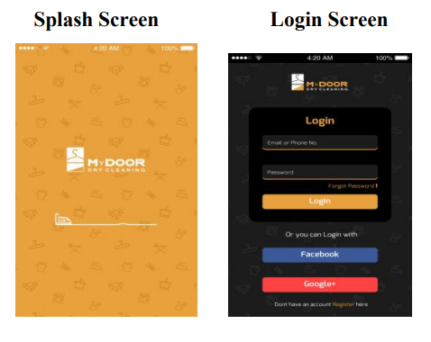

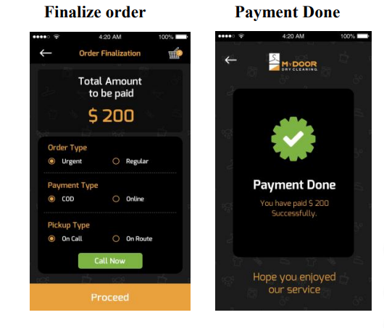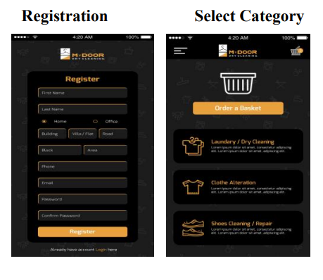**2.1.2 Problems with The Application**

**Figure 1: Laundry Service App**

They targeted people who are willing to order laundry services online. They are the administrator as well as the shop owner. Consequently, the customer does not have the option of selecting a specific shop from their list of options. They tried to be available everywhere, but they were not adaptable.

**2.1.3 Solution with IronMan**

In our, project IronMan solved the problem with the shops. Because we are an open platform, our primary goal is to act as a middleman between laundry shops and people. As a by-product, our app allows multiple shop owners to register their businesses. As a necessary consequence, people can select and order from any shop. IronMan also provides image classification, so people do not have to fear losing their clothes. It is a machine learning model that can detect Images from the database and verify the owner of the cloth.

* 1. **Project Background Related Application**

According to our most recent observation on research journals, there are already a plethora of well-known applications are gettable on Google Play and the Apple App Store.

Here are a few examples of popular and similar applications:

* Sheba.xyz **[10]**
* Laundry Vai **[11]**

In Bangladesh, many more related applications are available. Those applications have a lot in common, but they also have some differences and limitations. For instance, in the Sheba.xyz app, you can only communicate with one store, and there is no other laundry shop. Laundry Vai and Sheba.xyz are nearly identical applications to ours, but both have some limitations. These applications only contain information about their own services, only available within Dhaka.

On the other hand, IronMan is a fantastic platform for laundry services, with information on all local laundry shops throughout Bangladesh. These apps also do not allow customers to track their orders or provide convenient payment gateway services. We wished to develop an application that would give the same benefits across the country.

**2.3 Project Background Related Literature**

We conducted a theoretical literature review for this project. We reviewed what other researchers had written related to our topic to compile, categorize, and evaluate it.

First, we went through a paper named" IoT based laundry services: an application of big data analytics, intelligent logistics management, and machine learning techniques." **[12]** This paper discusses big data analytics, smart logistics management, and machine learning techniques used on an IoT platform for laundry services based on e-commerce. Data capture, storage, analysis, search, sharing, migration, visualization, tracking, updating, data privacy, and data sources are significant data analysis challenges. Data capture, storage, analysis, search, sharing, migration, visualization, tracking, updating, data privacy, and data sources are all big data analysis challenges. Using this data to make the program better is the central concept. Intelligent logistics **[13]** in real-time value networks enable customers to accurately navigate the entire life cycle of the transportation process, including purchases and contracts, shipment planning, execution and tracking, yard management, appointment schedules, and financial and claims settlement - all individually, cloud-based. Platform. A single connection to a real-time value network can connect you to the thousands of companies already signed on, including your partners and carriers. This is the network's worth. Other advantages include lower annual freight costs, better customer service, streamlined transportation processes, and reduced network inventory. In this journal, "IoT based laundry services: an application of big data analytic, intelligent logistics management, and machine learning techniques," They implemented Big data analytics, Intelligent logistics management, and machine learning to make the laundry service into an innovative IoT based e-commerce platform. They used Dijkstra's algorithm to find the shortest path **[14]** with the least amount of traffic and the least amount of distance. They collect all of the data and then analyze it using big data analytics. We took an idea and tried to put it into action in our work. We are also using machine learning techniques to test the sustainability of this idea by using people's thoughts about it as datasets.

The second paper we went through was "Food panda: Changing the Way Bangladeshis Eat Meals." **[15]** We selected this paper to understand the marketing better and promoting strategies and how to gather traffic and audiences so that our project "IronMan" can turn into a successful project. The following paper covers the part of the relationship between early business practices and companies' medium and long-term challenges and opportunities. It can give us an insight into our future challenges in building an e-commerce app, IronMan. The paper also discusses the food order process and delivery system. So we can use those ideas on our app to have a better delivery process so that our app can be sustainable and durable.

The third paper we read is "Customers' Use Intentions of Using Online Laundry Service." **[16]** The journal depicts the customer psychology of choosing an online laundry service. The following study aims to understand customers' intentions to use online laundry services through one-on-one interviews as the qualitative research method approach. The findings revealed that customers' preferences to use online laundry services were primarily influenced by the effectiveness and efficiency of such services. It is simple to use and saves time. As a result, we got an outcome of customers' behavior and attitude towards accepting the project that we made.

The fourth paper we read is "LAUNDRY SERVICE APPLICATION DEVELOPMENT

ANDROID BASED". **[17]** They researched to develop Android-based laundry services that are more efficient in terms of time to process laundry pickup, records of incoming and outgoing garments, and information on their own laundry OXY. The method employed includes a literature review, interviews, questionnaires, design, and testing. The paper assisted us in providing information such as price, type of service, and preferred laundry branch. It also aided in the monitoring of applications and operations.

The fifth research paper is "Laundry Services Application" **[18].** It shows a smart application that enhances the stipulation of a service that every home requires, Mainly washing clothes and household items in specialized laundry centers, as their application facilitates linking the user to the nearest laundry center. It would be easy for them to communicate with each other and provide the laundry service online via an online request submitted by the user. To accomplish this, they created an Android application that works on smartphones connected to the Internet.

***Chapter 3 - System Design***

IronMan's ultimate goal is to solve the problems that laundry shops face by creating an automated environment for laundry operations. **[19]** Taking orders, maintaining records, arranging delivery and pickup, and processing payments are all part of the process. The goal of "IronMan: An Android-Web Based Application for Laundry Services" is to improve operational efficiency, reduce costs, increase production, and effectively manage data across the system. We created three types of mobile applications to help us complete those tasks efficiently, which are basically for:

1. Shop owner,
2. Rider and
3. Customer

Aside from developing these applications, we also worked on developing a user-friendly website for our project. The website was created to assist people in viewing and comprehending our project's functionalities, working process, and usability. We can provide much more detailed information to our potential customers in a completely controlled environment with this website. In addition, we use the website to attract user attention to our product, bring together an audience interested in the product even before it is released, and obtain more installations once the product is released. As a result, it is in our best interests to create and promote a decent advertising website before the app is released.

We are also implementing a machine learning model with logistic regression to determine whether or not this project is sustainable and preferable. On the website, this model is used.

**3.1 Android Application**

We create three different apps to operate and navigate our project properly in this Android application part. Those are i) Shop Owner App, ii) Rider App, and iii) Customer App.

**Shop Owner App**: IronMan is built so that; local shop owners can place their shops online by using the application. At first, the shop owners have to register through our app to access it. After registering, shop owners can view the functionalities and have permission to access all the features. They can have their profile where they can edit their information. So after logging into the system, the shop owners have the luxury to:

* add their products
* remove any product
* modify the products
* edit the price list

Apart from these, the shop owners can access the order option. There they can see the history of previous orders and ongoing orders. Also, after finishing the order, shop owners can directly contact the rider to pick up the order.

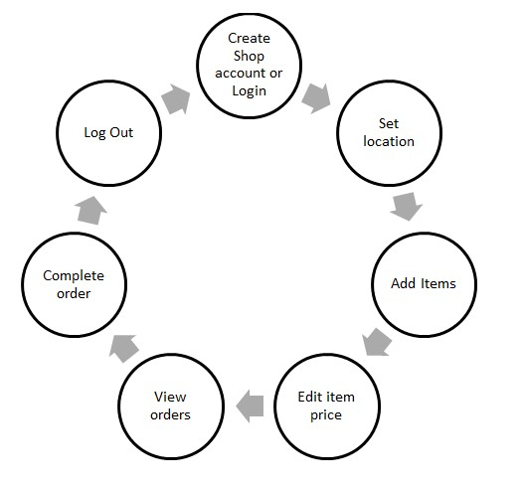

**Figure 2: Shop Owner App Diagram**

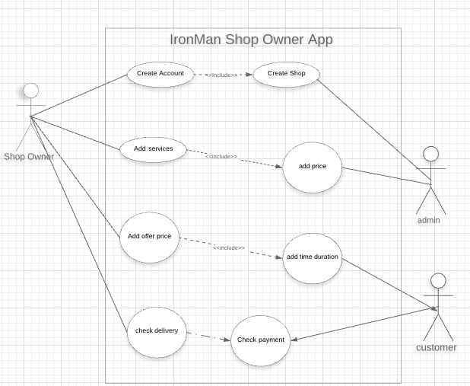

**Figure 3: Shop Owner App Use Case Diagram**

**Customer App:** Our application's focal point is the customer. As a result, we decided to create a separate application for customers to enjoy all of our project's features. Customers must first create an account and log in to the system using their email or phone number. Customers can see a variety of shops and their names after logging into the system. Customers can edit their profiles by clicking my profile bar if they desire. Customers must set their current location in the home page menu to access nearby local shops. They can select any store and place an order by clicking the add to cart button. They can then choose any payment method, such as card, mobile banking, or cash on delivery. Customers can view the order status after confirming their order. Customers benefit from viewing the real-time order process and the rider's location via GPS tracking.

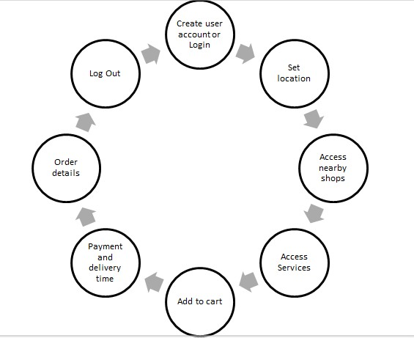

**Figure 4: Customer App Diagram**

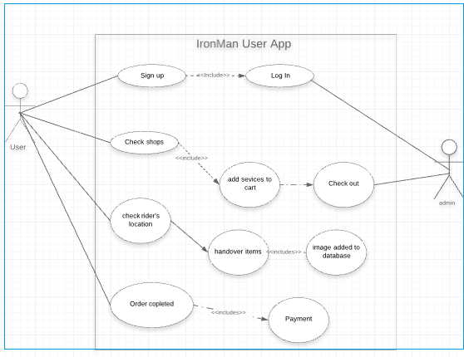

**Figure 5: Customer App Use Case Diagram**

**Rider App:** We created a rider application to connect customers with shop owners. Essentially, there will be many riders willing to work as delivery men. To work as a rider, he must first register through our Rider app by providing the necessary information. After that, he will have access to the system. When a customer orders, a notification will appear for the rider closest to that customer.The rider can then accept the pickup request. After picking up the products from the customer, the rider must deliver them to the shop chosen by the customer. After finishing the laundry, the shop owner can direct contact with the rider to provide the product to the customer.

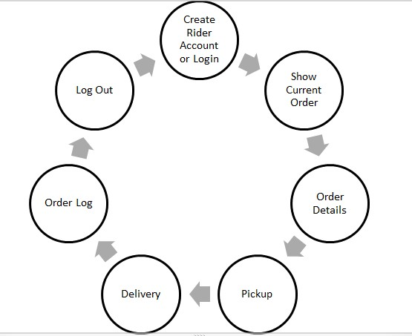

**Figure 6: Rider App Diagram**

**Figure 6: Rider App Diagram**

**Figure 6: Rider App Diagram**

**Figure 6: Rider App Diagram**

In addition, the rider can view the order log history, payment history, reviews, and ratings.

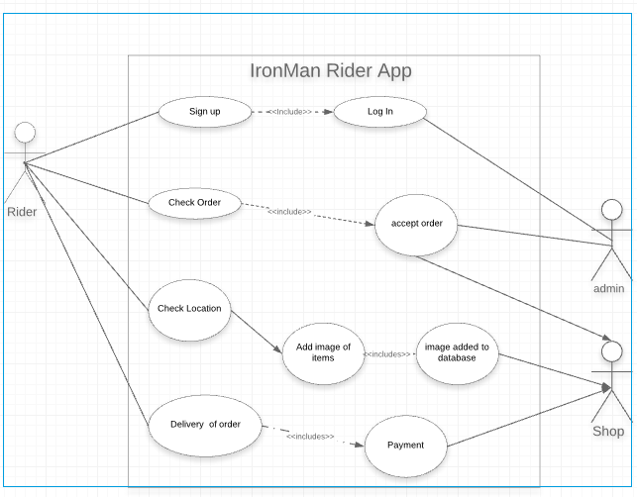

**Figure 7: Rider App Use Case Diagram**

**3.2 Web Based Application**

The IronMan website will include a user panel with product showcasing, login and signup application, and a search of laundry shops nearby users and services the user desires. On the other hand, there will be a Shop user panel where owners can decorate their shop by creating an account and adding all their services with pricing. These sections will have an administrator who will connect these users and enable the E-laundry service.

**The customer panel includes**-

* Customer Log in
* Locate nearby laundry service providers
* Selecting laundry services
* Select pickup and delivery date
* Request for Laundry
* Track Laundryman
* View Order status
* View order history
* Write the review and share the experience

**The Shop Owner panel includes-**

* Log in/Sign-up
* View and manage profile **–** Manage Laundry Charge
* View Order Request
* Manage Order and its Status
* View Order History
* View Reviews and ratings

**And the Admin panel includes**-

* User Management
* Managing Category Manager
* Manage Payment

For our machine learning model dataset, we created a survey with questions about people's opinions on the idea of E-commerce-based laundry service. We then convert the responses to CSV files and use them as datasets. Link to the survey Questionnaires: **[20]**

• Your Age 15-20(9.6), 20-30(86), Above 30(4.4)

• Do you use laundry shops in your area? Yes (85.1), No (14.9)

• How often you use laundry of your area? Once a week (38.4), Once a month (29.7),

More than once a month (19.7), Never (12.2)

• How much you spend for laundry services? 500 BDT per month (17.5), Less than

500 BDT per month (71.6), More than 500 BDT per month (10.9)

• How many clothes you would like to provide per week? Less than 5(52.6), More

than 5(36.4), More than 10(11)

• Which Division do you live in? Dhaka (42.4), Chattogram (32.3), Rajshahi (17.9),

Khulna (1.7), Barishal (0), Rangpur (1.7), Sylhet (2.6), Mymensingh (1.3)

• Do you use smartphone? Yes (99.1), No (0.9) Do you have access to Internet at

home? Yes (98.2), No (1.8)

• Will you use a Mobile Application for laundry services in your area? Yes (59.4),

No (40.6)

• If it charges you delivery fee for laundry services will you pay? Yes (62.9), No

(37.1)

• How much time are you willing to provide for the laundry service? Less than 24

hours (46.5), Less than 48 hours (30.3), Less than 72 hours (6.1), No tension about

time (17.1)

• Which time of the day you expect the clothes to be picked up or delivered? Morning

(23.2), Afternoon (24.6), Evening (52.2)

• Do you appreciate the fact that you will be able to avail laundry services from your

doorstep? Yes (92.6), No (7.4)

• Which payment method you prefer for this kind of services? Mobile financial

services (bKash, Nagad, etc.) (24.6), Card Payment (4.4), Cash On Delivery (71.1)

• Will you recommend this service to others if it turns out to be satisfactory? Yes

(95.2), No (4.8)

We convert all the categorical data into numeric data. **[21]** For Yes and No, we set 1 and 0. And for other questions, we give serial-wise numeric values like 1,2,3,4. We drop null columns. We set the score to determine sustainability using six questions. Do you use laundry shops in your area? Do you use a smartphone? Do you have access to the Internet at home? Will you use a Mobile Application for laundry services in your area? If it charges you a delivery fee for laundry services, will you pay? Do you appreciate the fact that you will be able to avail laundry services from your doorstep? Will you recommend this service to others if it turns out to be satisfactory? Based on this we set highest score as 10. Set the results as below:

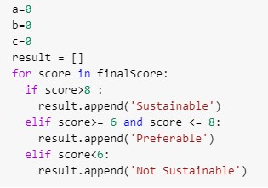

**Figure 8: Score Set Code**

Originally, logistic regression was not a regression model but rather a classification model. Logistic regression is a simple and efficient method for binary and linear classification problems. It is an easy-to-implement classification model that produces excellent results with linearly separable classes. It is a widely used categorization method in the industrial world. The logistic regression model **[22]** is a statistical method for binary classification **[23]** that can be extended to multi-class classification. **[24]** We train our logistic regression model. We give 70 percent data into the train set and 30 percent data into the test set for training. We get the results Logistic Regression with no regularization Train Accuracy:

1. Test Accuracy: 0.8636363636363636

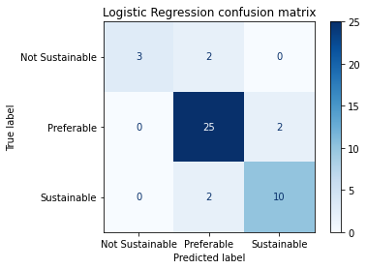

**Figure 9: Confusion Matrix**

We used logistic regression to simplify our future perspective to determine "IronMan: An Android-Web Based Application for Laundry Services" Sustainability. If we wanted to evaluate the survey manually, it would have taken a lot of time. Using the logistic regression model, we can simply classify data from website survey results. The more response we get from the survey, the more influential the model will be. Then the regression model would give us insight into whether "IronMan: An Android-Web Based Application for Laundry Services" would be sustainable.

***Chapter 4 - Software Tools***

**4.1 Android Development Tools**

* Android Studio (Android Framework, Java)
* Fire-base (Database Framework)
* Google cloud platform

We used Android Studio as an android framework for development, and the programming language is Java. We chose fire-base as our database framework. We use fire-base as a real-time database to store data and information about our application. A non-relational database is a Fire-base database. Fire-base is a useful framework for developing a portable web application with a real-time database. When a user updates a record in the system, the update is sent to all users, regardless of whether they are on a site Web or an Android device. We used the Google Cloud Platform to integrate Google Maps into our application. To integrate Google Maps into our mobile app and website, we used a combination of APIs and SDKs.

**4.2 Web Development Tools**

* HTML
* CSS
* Python
* React JS
* Django
* DialogFlow
* Kommunicate

We started with HTML and CSS as web development tools. We used HTML to structure our web page and CSS to describe how HTML elements should be displayed on the screen, which allows us to make the web page colorful, static, and well-designed. We once again used Fire-base to store the database. We used React JS for our back-end operation. It has been used to manage the view layer for web and mobile apps. We wanted to create a user interface that would be reusable. So we used React as it has the features for that components. Django is a popular open-source, accessible, and high-level web development framework. It provides a plethora of features to developers "out of the box," allowing for rapid development. On the other hand, websites built with it are secure, scalable, and maintainable. To implement Chabot, we used DialogFlow and Kommunicate.

**4.3 Machine Learning**

* Google Colaboratory
* TensorFlow Lite

For machine learning, we trained a logistic regression model. TensorFlow Lite is used to image classification.

***Chapter 5 - Methodology***

Through our project, we hoped to create an integrated system comprised of an android application and a web application and implement machine learning techniques. The first section focuses on developing the website, while the second section focuses on developing three different Android applications and implementing machine learning.

**5.1 Web Development Approach**

For web development, we used PyCharm IDE. In PyCharm, we easily edit our codes as the compiler is made for the Python programming language. The add ones, smart code features are the reasons to use PyCharm IDE.

**Figure 10: Creating a project on PyCharm**

We have used Django as a framework. So that we can easily create the HTML page of the website and store the database in the Django administration, from there admin can control the whole website and do have access to read and write and modify anything.

URLS

(urls.py)

URLS

(urls.py)

URLS

(urls.py)

URLS

(urls.py)

HTTP request

Forward request to appropriate view

Forward request to appropriate view

Forward request to appropriate view

Forward request to appropriate view

Read/Write Data

Read/Write Data

Read/Write Data

Read/Write Data

View

(views.py)

View

(views.py)

View

(views.py)

View

(views.py)

Model

(models.py)

Model

(models.py)

Model

(models.py)

Model

(models.py)

HTTP Response

(HTML)

HTTP Response

(HTML)

HTTP Response

(HTML)

HTTP Response

(HTML)

Template

(IronMan.html)

Template

(IronMan.html)

Template

(IronMan.html)

Template

(IronMan.html)

**Figure 11: Django Home Page for website**

Then we used Model View Template (MVT) design pattern to architect our website. The MVT pattern allows us to test different combinations of elements on the same page to see which one produces the best results. Using the MVT pattern determines which variety of variations out of all possible combinations performs the best.

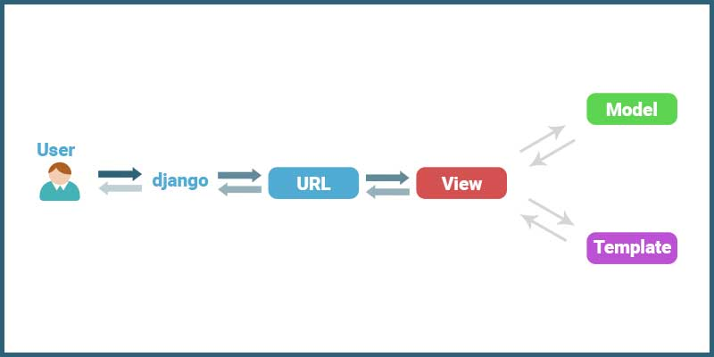

**Figure 12: MVT Pattern Diagram**

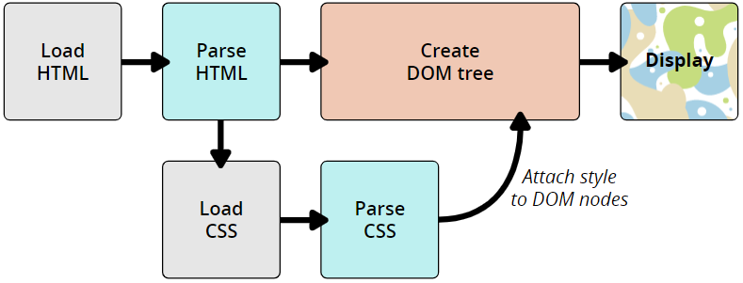Then we used HTML & CSS to give a better shape and look to our website. We have linked the HTML contents with CSS files. So it will be much easier to add the CSS style and design to the website. CSS will act to that and instruct the index.html file to render and exit from the HTML index.

**Figure 13: HTML-CSS Process**

After creating the website, we also implemented a Chabot. For that, we used Google DialogFlow and Kommunicate. DialogFlow is a natural language understanding platform that makes it easy to create and integrate a conversational user interface into a mobile app, web app, device, or bot. **[25]** Kommunicate is a human+bot hybrid customer support automation platform that provides growing businesses with real-time, responsive, and customizable support.

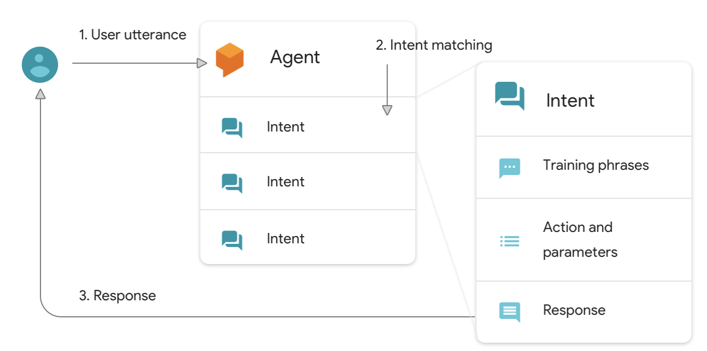

**Figure 14: Deconstructing Chabot Using DialogFlow**

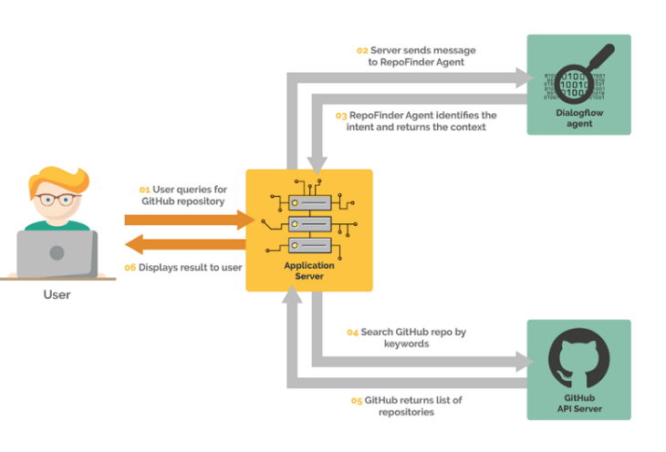

**Figure 15: Kommunicate APIs Using DialogFlow**

**5.2 Android Development Approach**

To develop the android application, we have used the android studio as a unified environment where we can create apps for Android devices. In the android studio, first, we needed to create a project and then select some dependencies. Then we needed to build the Gradle. The Android System supports Gradle because it is used to build automation tools. Android's application framework compiles the resources and Java source code before being packaged into an Application System. This package is ready for testing and deployment.

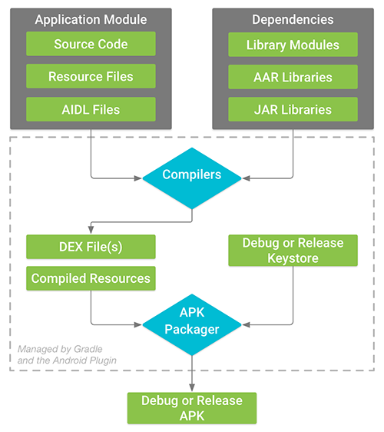

**Figure 16: JAVA-Gradle’s Involvement**

Here Gradle builds the process by merging .class and .dex files. After that, Gradle builds a .apk file along with a .dex file. Then the file is ready to debug. We have created customer app, rider app, and show owner app by using android studio.

We have also used image classification. For that, we used TensorFlow Lite and a teachable machine. In TensorFlow Lite, we deploy some models to classify the images. It is one kind of machine learning process to object detection.

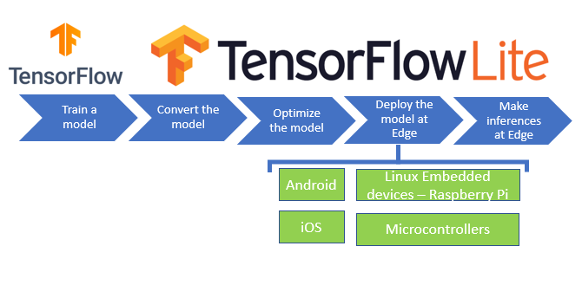

**Figure 17: TensorFlow Lite Work Process**

As we can see in the chart, 1st, we train some models. In the models, we have deployed some images related to a shirt, pant, t-shirt, etc. Then we converted the model, optimized it, and deployed that model in our android studio project. In teachable machine, we have trained the datasets of images and imported the model as .tflite in android studio.

***Chapter 6 - Experimental Setup***

**6.1 Hardware Requirement**

For android and website development, the requirement is not so expensive. So a standard desktop with a measured configuration will work for the project.

|  |  |
| --- | --- |
| Components | Description |
| CPU | Intel Core i7 (seventh generation or newer) or equivalent |
| GPU | 4 GB |
| RAM | 8 GB |
| Operating System | Microsoft Windows 10 x64 |

**Table 1: Hardware Specification**

**6.2 Software Requirement**

There is no specific requirement for software. For the website, it can run on any python and Django-related version. Also, for android studio, any SDK and JDK version is applicable.

***Chapter 7 - Result & Analysis***

We discovered that the project "IronMan: An Android-Web Based Application for Laundry Services" almost works flawlessly after individually analyzing our system. We have successfully implemented the prototype of the entire system, as planned initially. We have also divided this part into two. We will use our final application demonstration for the result, and to analyze our project, we have conducted some qualitative research.

**7.1 Analysis of Results of Web Development**

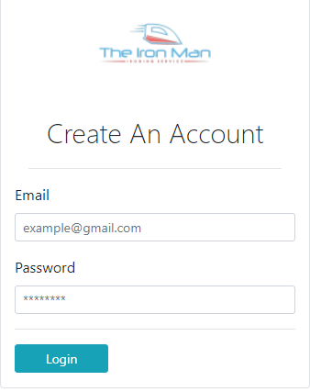For the website, we have created a signup page at first. Then after registering, the customer can sign in to the system.

**Figure 19: Login Page**

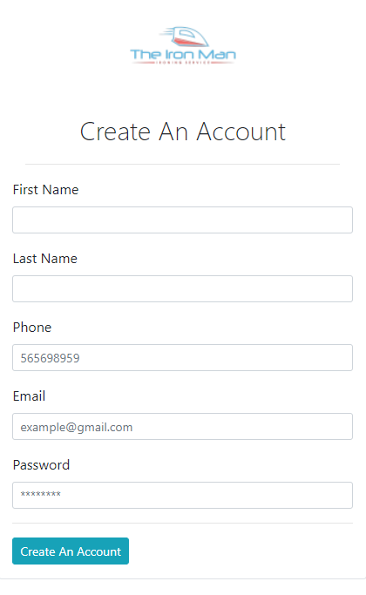

**Figure 18: Sign Up page**

After logging into the website, customers can view the whole dashboard. There are different products from 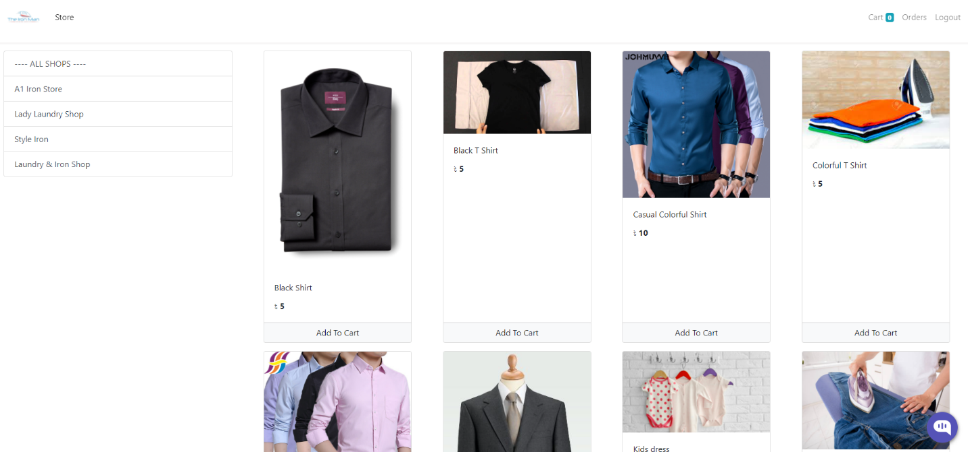different custom laundry and iron shops.

**Figure 20: Home Dashboard**

Then the customer can select any products from any shops they like to order. They can increase or decrease the order. After ordering the products, they view them in the cart. The system will show the details like price, quantity, and total amount.

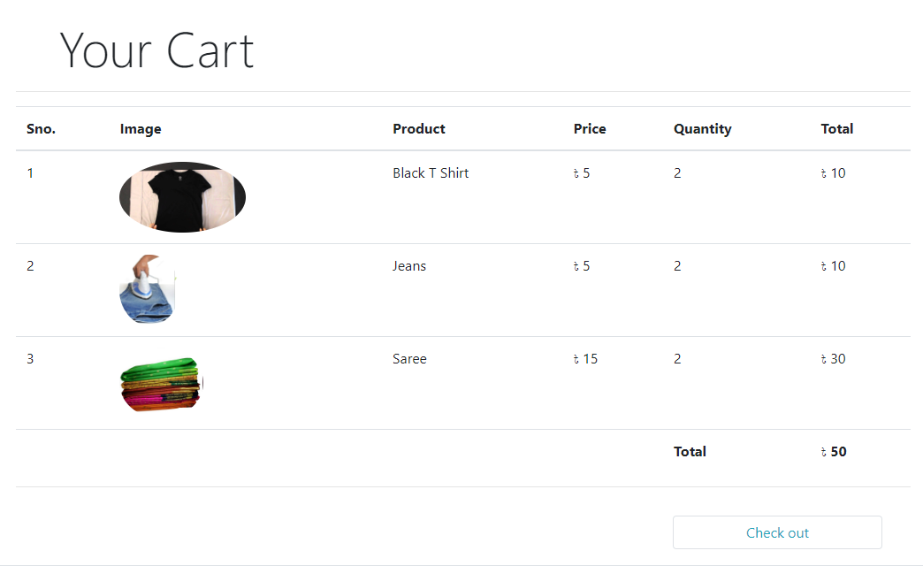

**Figure 21: Cart**

After that, the customer can check out by giving the related information like their address and phone number.

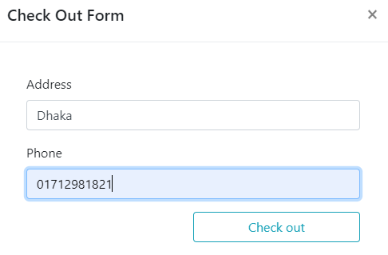

**Figure 22: Check out Form**

There is an order menu to view the orders or check the orders. From there, customers can view the products they ordered. Also, they can check the order status.

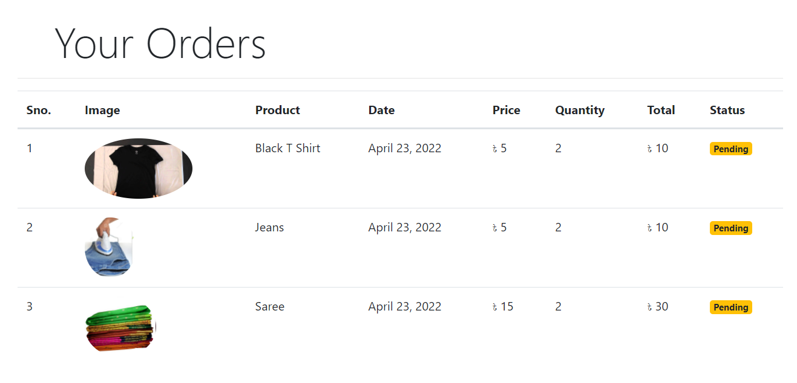

**Figure 23: Order Status Pending**

There is also a system where the admin can control the order status. If the order is done, the page will show the completed status.

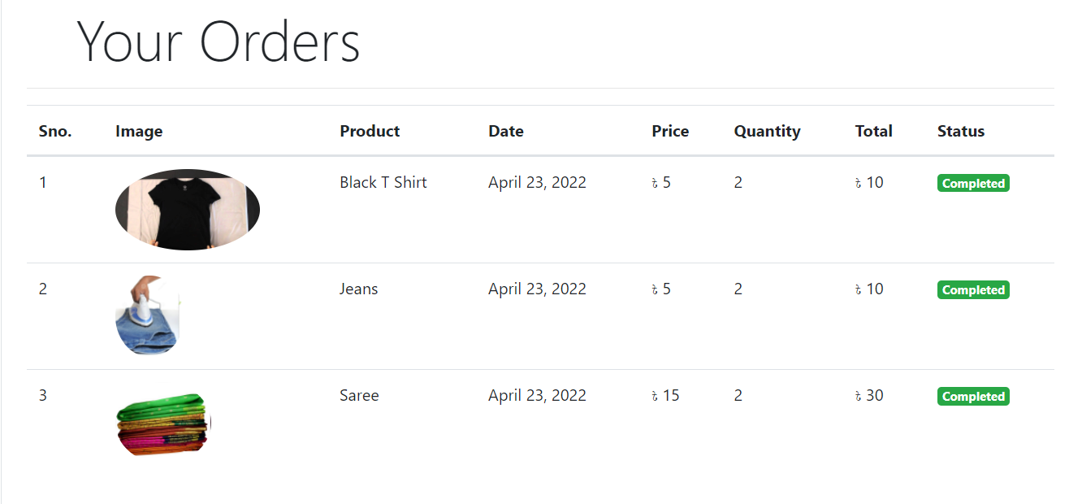

**Figure 24: Order Status Complete**

We also have set up a Chabot where people can ask their queries. Manually we have implemented some intent on Chabot.

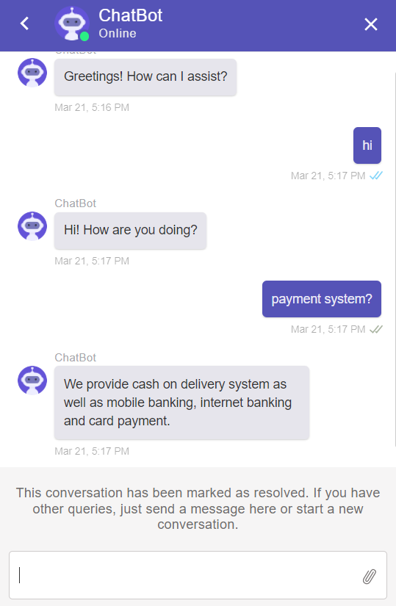

**Figure 25: Chabot**

**7.2 Analysis of Result of Android Development**

* **Shop Owner App:**

For Android development, we have created the shop owner app first. Any shop owner can register their shops by filling out the signing up page.

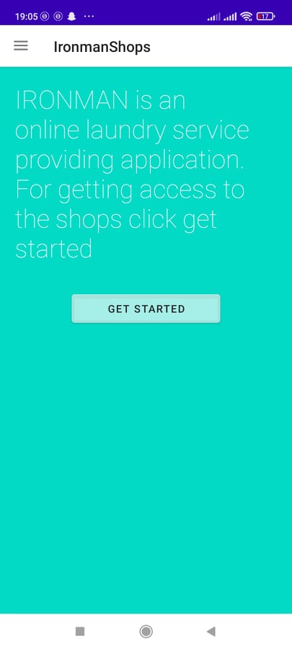

**Figure 26: Shop Owner App Interface**

Shop owners can view their profiles as well as the orders. They can update the products and prices also. After updating, it will show the updated details on the product page.

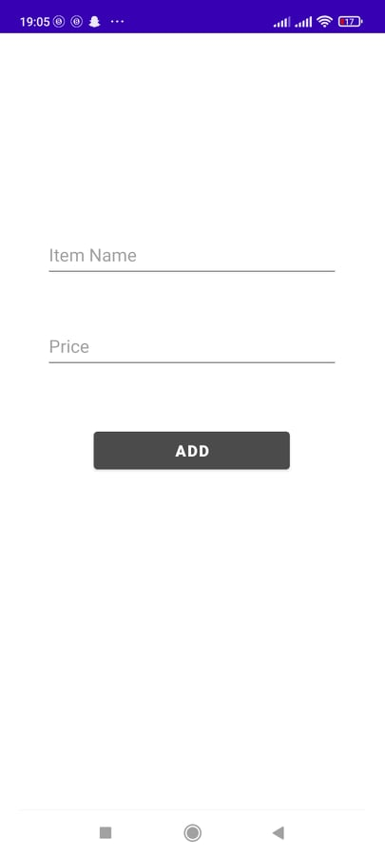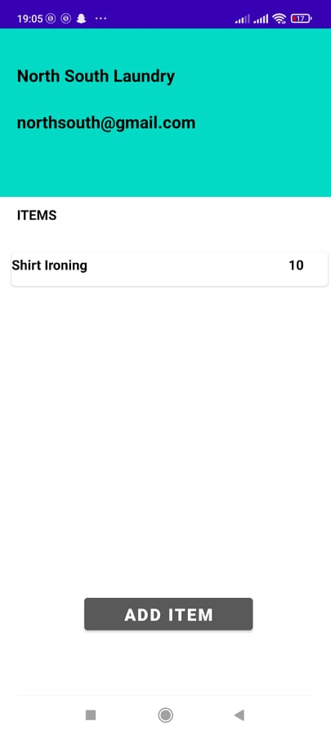

**Figure 27: Shop Owner Customizing Product**

When the shop owner clicks on the 'Get Started' button, he can see the new page where he can update the products and their price. After filling those items, he must click on the 'Add' button. Then the product and its' price will be updated.

* **Pricing of The Products:**

Initially, the shop owners can update the prices of the products according to their preferences. However, we have just made a template for updating the name of the products and prices. After registering in the app, shop owners have the authority to edit them. We have already made a survey asking different questions to different shop owners. They told us that they had set different prices for other products. They have asked us whether they could update the pricing as per their liking or not. We assured them that that feature is available and flexible in our app.

* **Rider App:**

The next android application is for the rider. The rider will pick up the products from the customer's home, and after completing the ironing at the shops, he will deliver them to the customer. But firstly, the rider has to sign in to the app. Then he can see the orders that have come from the customers. After that, he can see the order details and prices through orders.

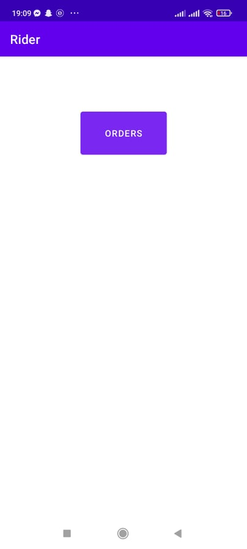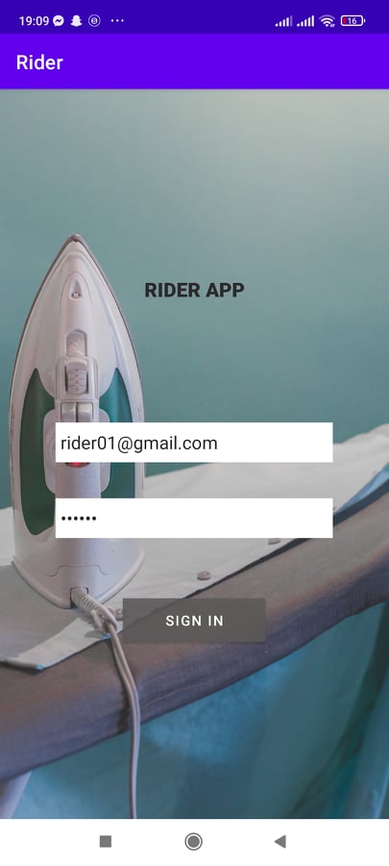

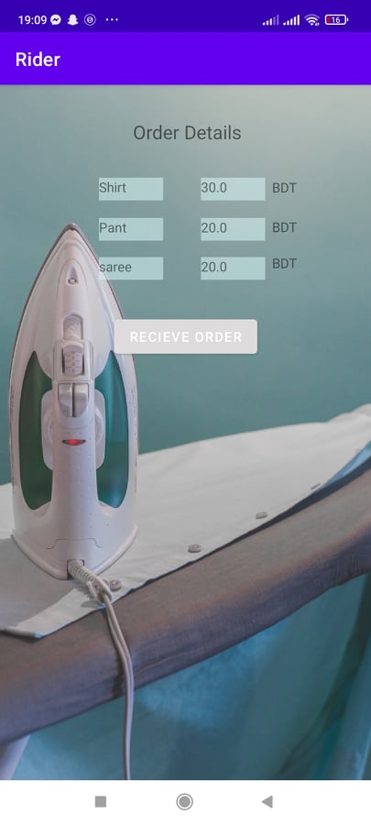The rider also has access to the image classification tool. He can check the clothes through image classification. It will assure the customer that their products will not be lost. Image classification will show the percentage of confidence whether that is the correct product.

**Figure 29: Order Page**

**Figure 28: Login page**

**Figure 30: Order Details**

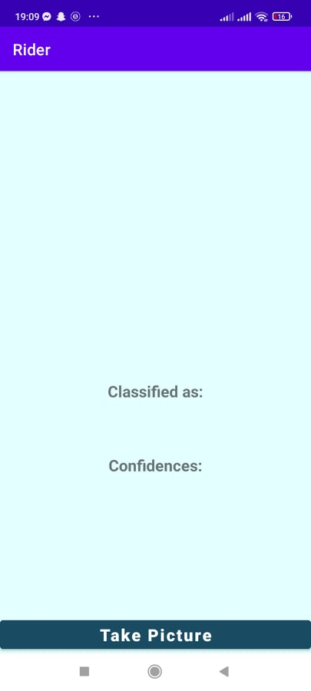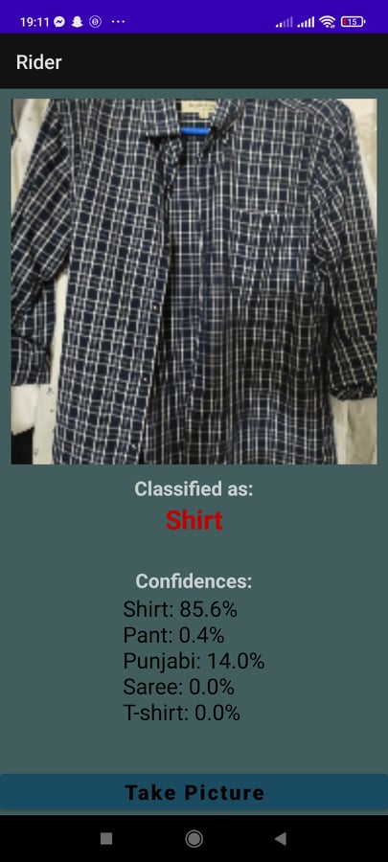

**Figure 31: Image Classification for Rider App**

* **Customer App:**

There is also an app for the customer. Customers need to register through their mail, and then they can access their profile.

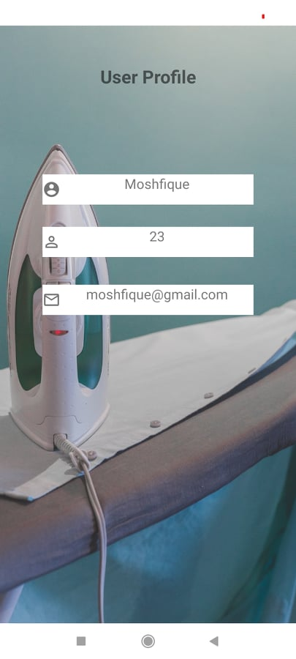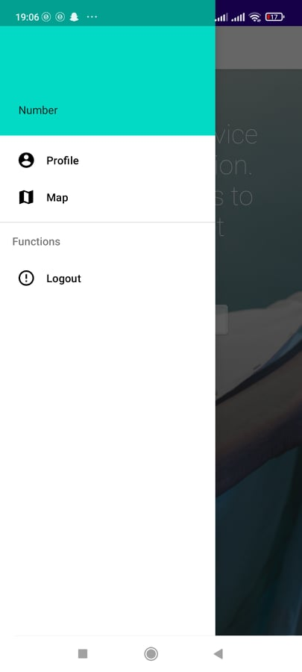

**Figure 32: Customer Profile**

Customers can have access to Google Maps, where they will be able to see the current location. Also, they see different laundry shops that are registered through the app. Then they can choose any shop and order from that shop.

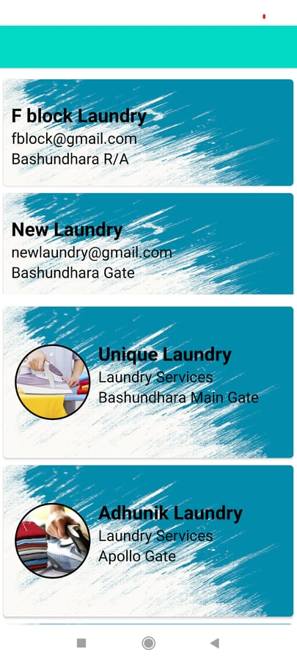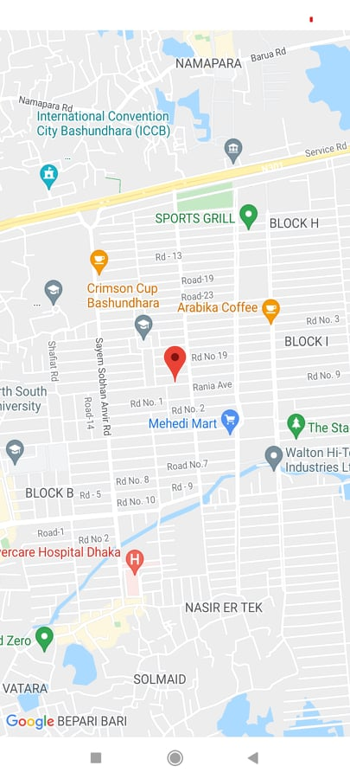

**Figure 34: Registered Shops**

**Figure 33: Current Location**

After ordering from their particular liking shop, customers can view the cart and total amount of money.

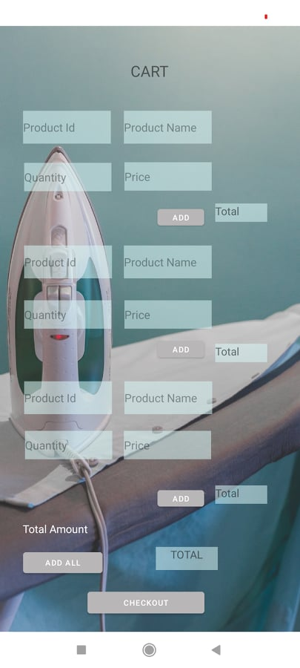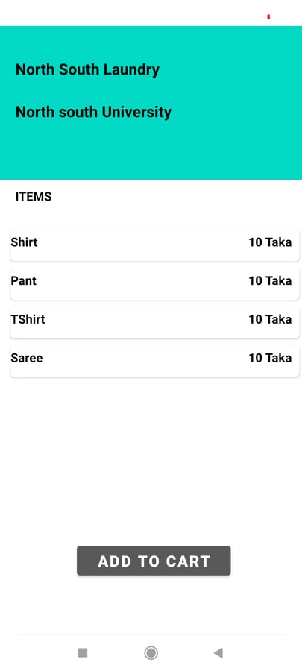

**Figure 35: Customer Cart**

* **Image Detection:**

TensorFlow Lite is used for image classification. Our idea was to keep an image classifier in the rider app for instantly taking an image in real-time when picking order and adding the Image to the user's database for a future claim. We have used Teachable Machine learning to train our model by gathering images of categories like shirts, T-shirts, saree, Punjabi, etc. And then used TensorFlow Lite to add it to our Rider app and save the data to individual customer's databases using Firebase.

Image classification is an essential concern in which a set of target classes is defined, and a model is trained to identify them using labeled example photos. We have used numpy, Opencv, and PIL (Python Imaging Library) libraries for training.

Training the model requires the following steps: **[26]**

1. First, we need to provide the model with some training data.
2. Then the model tries to immaculate the provided images and labels.
3. After that, the model predicts the test sets.
4. Lastly, the model verifies whether the predictions match the labels or not.

The output of Our Rider App:

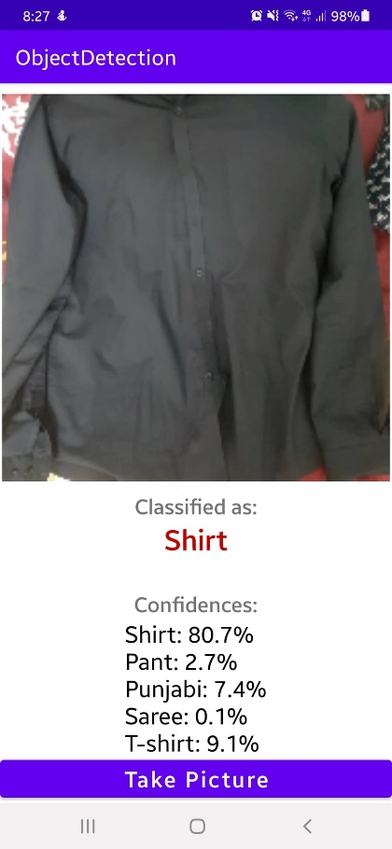 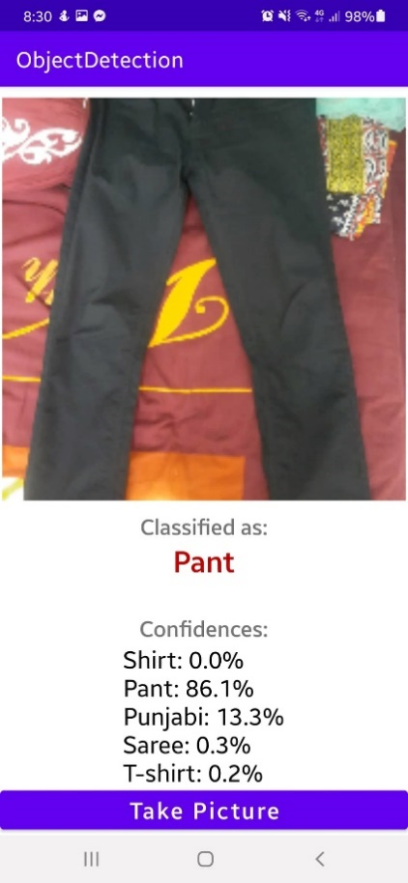 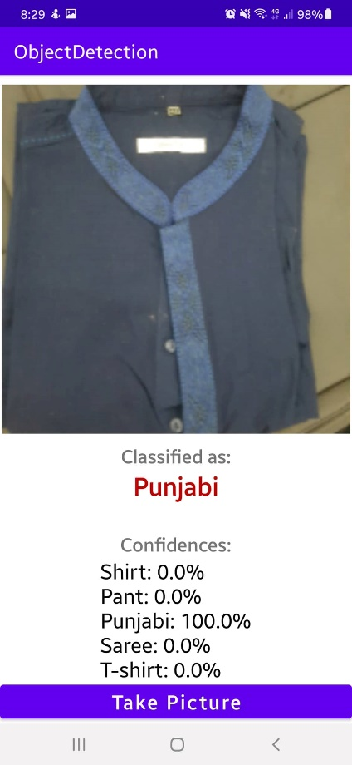

**Figure 36: Image Classification**

As shown in the above figure, after the rider takes a picture of items, the model can recognize the Shirt with 80.7% confidence, Punjabi with 100%, and Pant with 86.1%. The accuracy of the model will increase as more data gets added.

When the rider captures the images after taking the clothes from the customer, the photos will be saved to our database. When the rider is about to deliver the product back to the customer, he can check the product. The rider will click the images, and then the app will search the photos from the database. There will be the owner's name saved by their clothes images in the database. After that, the app will show the name of the owner of the clothes. Some snip shot of the image detection is given below:

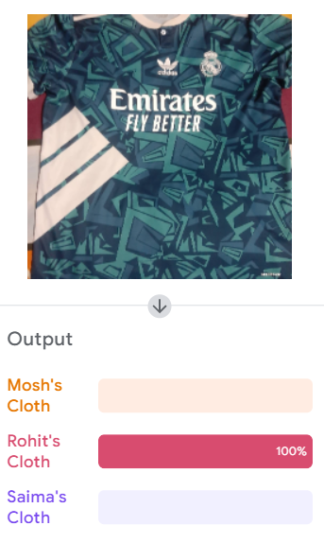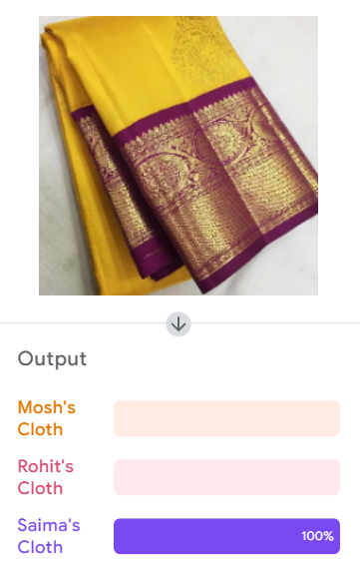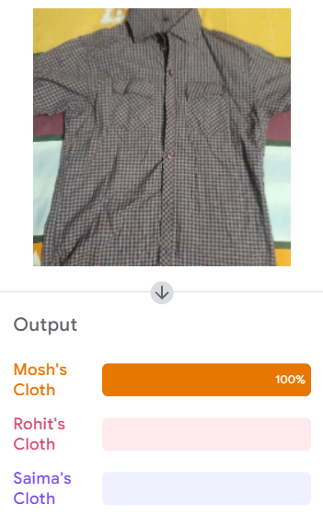

**Figure 37: Clothes Owner Image Detection**

As we can see that the app will detect the owner's name through the database, then it will return the name of the owner matched by the Image of the clothes. After completing the ironing, the shop owner can check the owner of the clothes by using the feature of image detection from the database. Thus, every clothe will be scanned and will reach its actual owner, and there will not be any situation of mixing up any clothes.

**7.3 Qualitative Survey**

We surveyed the understating of the local laundry shop owners regarding our project 'IronMan.' We showed our demonstration of the application to them and asked them how they felt about our app. We also asked them some frequent questions about the sustainability of the project idea and if they are convenient and comfortable enough to use the mobile application.

1. Wash Clean Laundry & Dry Clean:

* Location: Ghatpar, Bashundhara
* They have their own home delivery service.
* They are not interested in such a project as they are already raising their reputation through their business policy.
* They will not use the mobile app because they think it will be an extra hassle to maintain their business.
* They took orders through phone calls.

1. Khandani Laundry & Dry Cleaner:

* Location: Ghatpar, Bashundhara
* They have their home delivery system through phone calls.
* They thought our project idea was good, but currently, they are not interested in investing in our project. However, they will think about it in the future.
* Initially, they were not clear about the project because they thought they had to employ an employee/delivery man. But when we explained the middle man process that the company would hire a delivery man, they seemed convinced and their response was positive.
* They are comfortable using the mobile application to manage all the orders and products.

1. Adarsho Laundry & Auto Dry Cleaner:

* Location: Ghatpar, Bashundhara
* They have their home delivery system through phone calls.
* They had previously used a third-party delivery system.
* They are interested in our project.

1. Nana Tailors Auto Dry Cleaner & Laundry:

* Location: Ghatpar, Bashundhara
* They have their home delivery system through phone calls.
* They are not interested in our project. They have some trust issues regarding registering their shops. Also, they think that it will be worrisome to manage extra clothes.
* They are not ready to use the technology, so they refuse to use the shop app.

1. Cumilla Auto Dryers & Cleaners:

* Location: Ghatpar, Bashundhara
* They have their home delivery system through phone calls.
* Initially, they declined our project idea, but when we explained that the company would assign an additional delivery man, they seemed happy to invest in our project.
* They are not eager to use the shop application as they are not used to android applications. But if the company provides the device, they are willing to participate.

1. Bhai Bhai Laundry:

* Location: Ghatpar, Bashundhara
* They do not have a home delivery system.
* They liked the entire project idea, as they think it will be a good opportunity for them to get a good amount of exposure in Bashundhara.
* They are willing to use the shop app.

1. Alif Laundry & Dry Clean:

* Location: Bashundhara Gate
* They have their home delivery system.
* They liked our idea, and they were willing to participate. Because the home delivery system they are using now is causing them extra money. But when we said that the project idea would assign a home delivery man, they thought it would be a good opportunity.
* Therefore, they are willing to use the shop app.

1. Chomok Auto Dry Clean:

* Location: Bashundhara Gate
* They do not have a home delivery system.
* They have been running their business for 28 years. So they have a strong base of customers. However, they liked the idea of our project.

1. The White Clean & Auto Dry Cleaners:

* Location: Bashundhara Gate
* They have their home delivery system.
* They appreciated our project idea, but they have a substantial customer order. So they are afraid that if they participate in such a project, they will not be able to complete the orders in due time.

1. New Exclusive Laundry & Dry Cleaners:

* Location: A Block, Bashundhara
* They have their home delivery system.
* They want to involve in our project as they liked our idea.
* They are willing to use our shop app.

1. Sun Laundry Dry Wash:

* Location: A Block, Bashundhara
* They have their home delivery system.
* Their shop is not very popular, so they think if they are involved in our project, they will be able to set up a solid customer base.
* As a result, they are willing to use the shop app.

1. Tahsin Auto Dry Cleaners & Laundry:

* Location: A block, Bashundhara
* They have their home delivery system.
* They liked our project idea very much, and they instantly wanted to involve in our project.
* They thought the idea would give them vast exposure, so they wanted to use the shop app.

1. Woolite Auto Dry Cleaners & Laundry:

* Location: A block, Bashundhara
* They do not have a home delivery system.
* Though they have a strong base of customers, they see this project as an opportunity to grow their business further. So they are eagerly waiting for the project to launch and be a part of it.
* Also, they are willing to use the shop app.

**Evaluation of The Survey:**

After gathering the information and data from the different shop owners from other places, we realized that they were initially not sure or were not clear enough about the project process. They thought it would be an extra hassle for them to appoint a delivery man, or some thought it would negatively impact their business. But when we explained our project method thoroughly, that is when they seemed clear about our project. So the majority of the shop owners are willing to participate in our project and appreciate our ideas. In short, the small shop owners see this as an opportunity to grow their business and set up a solid customer base. Whereas middle and large shop owners appreciate our project, they are currently not ready to be involved in our project. From the survey, we got the idea that if our project appoints a go-between or delivery man, most of the shops are willing to be involved instantly. Overall, our project, "IronMan: An Android-Web Based Application for Laundry Services," seems sustainable to them. It is an excellent possibility that our project might be successful in the near future.

***Chapter 8 - Project Impact***

**8.1 Environmental Consideration & Sustainability**

People always comply with the straightforward path alongside easier reach the destination outcome. It is the main reason online business e-commerce platforms have expanded with the advancement of technology. Our project IronMan expects that it can make regular laundry services smoother and more accessible. In standard laundry system, people have to face some hassles like they need to find extra time for taking the clothes physically to the shops, again for receiving cloths, some extra hassles like order are not fulfilled under the promised time, sometimes shop keepers make mistakes like losing customer cloths by delivering it to wrong customers. Turning these manual processes into a tech-organized automated process can solve the above issues. How people will react to such a tech outcome: We already have built a machine learning model to check if this idea is sustainable or not using people's thoughts about this project. This already gave us a promising result. We also went through the local shop owners and took their recommendations and thought about the project cause without their interest, which cannot be sustainable. We got promising results here also. People can easily experience their clothes being prepared through one tap on their mobile phones, which saves time. Alongside this, as our life gets more accessible by using external services and applications, the environment does get the effect by this or that. The old-fashioned way to promote laundry services and their offers is by printing them on posters and leaflets and handing them to people personally. And we all know that at the end of the day, nobody reads them; instead, a massive amount of paper gets thrown away and wasted in the bin. Our app will help these shops to promote their offers and discounts online without wasting any banners, leaflets, and papers.

**8.2 Usability, Manufacturability, and sustainability**

Our project creates a new platform for all types of shops that offer cleaning and laundry services. Currently, most laundry shops have started to design their app or website in Bangladesh. But it is very inconvenient for a user to download so many apps; that is where we come in handy. Through us, customers can check the prices of different shops in their area and then choose their desired service at the lowest cost. Thus, it is more sustainable for users. And as our app is a media between the shop owners and the users, we would only have an admin sector that will handle the operation or help when needed; thus, we do not require any manufacturer. As we build our app with complete applications of our thoughts, the next job is to provide real-time updates and bug fixes for the app that developers can quickly do by developers single-handedly. As one of the primary users will be the shop owners who need to maintain the shop owner's app, there raises a question of that are they willing to use such an app or it is easy for them to handle such an app for maintaining the regular business, our survey on traditional local shop owners can portray this question's answer quite clearly. We showed them our build app and asked their thought about this. Almost everyone is familiar with using an innovative app to handle a business, as today's world is technologically advanced. They gave us positive reviews about our app as it is pretty straightforward in terms of use, easy UI, and less functionality. We need to provide usage guidelines properly during the training period. We need to do some pilot promotional campaigns to promote such an idea. Our survey of users has also portrayed that people are aware that these beliefs can help them lead a regular hassle-free life; they are also willing to promote our business to their nearby friends as it is a handy idea.

**8.3 Modern Analysis and Design Tools**

To generate such new ideas and turn them into successful working ideas, there need to be some steps. We kept in mind the real-time problems. Following them, we created our rider app using image classification, which takes the Image of the items given and records them using image classification for an error-free experience and easy product claim service. This service is provided only by us, and in this fast delivery service time, this will reduce the misplacement of products. We also have added the location feature in our customer app so that the user can check their riders and their locations. For a project, it is the main thing whether the idea is sustainable or not. Using their responses, we have already surveyed how people think about this innovative idea, and we build a machine learning model that can predict sustainability. We will take every user experience data to grow our dataset and use them in our linear regression model, which can provide us with results about the sustainability of this project. Our design tools are also handy. Firebase framework **[27]** makes our work smoother in handling our database and authentication. In terms of graduation, we can follow our linear regression model outcome and implement that for proper upgradation.

***Chapter 9 - Conclusion***

Iron-Laundry Services is a service that is required regularly. People increasingly rely on e-commerce and internet-based jobs to help them manage their lives. Our project aims to make laundry services more accessible to the general public. We have developed e-commerce laundry services and brought all local laundry shops together on a single platform. In addition, we worked on Android and web-based applications. And to improve the user experience, we planned to add features related to big data analytics, intelligent logistics management, and machine learning models. We have already taken people's opinions on this project idea as a survey and turned them into datasets, which we used to train our logistic regression model and determine whether or not this work will be successful. To launch this as a pilot project, we needed to conduct qualitative research among local laundry shops to see if they are interested in such an idea or are ready to take their businesses online. That is something we have already done. We need to do fieldwork before launching it as a pilot project. The main question, in the beginning, will be feasibility; we will need to teach local shop owners how this project will work, its benefits and drawbacks, and so on. We hope that Ecommerce based laundry can make a considerable change in the e-commerce industry.

**9.1 Future Work**

We worked on developing an android application and web development. We trained a logistic regression model. We are studying big data analytics, intelligent logistic management, and machine learning in detail. We are determined to add some features related to this topic in our work. We will implement our logistic regression model on our website. Though we have made a simple prototype for this project, we have a plan to build this as a pilot project that would be business effective. However, we need to work on our user interface and add some features like shortest path distance, location tracker, user app notification system, etc. We intend to work on proper app and web development and complete unit testing in the future.

***REFERENCES***

[1] L. D. Xu, W. He and S. Li, "Internet of Things in Industries: A Survey," in IEEE Transactions

on Industrial Informatics, vol. 10, no. 4, pp. 2233-2243, Nov. 2014.

[2] S. Singh and N. Singh, "Internet of Things (IoT): Security challenges, business opportunities

& reference architecture for E-commerce," 2015 International Conference on Green Computing

and Internet of Things (ICGCIoT), 2015, pp. 1577-1581.

[3] Congzheng Song, Thomas Ristenpart, and Vitaly Shmatikov. 2017, "Machine Learning Models that Remember Too Much. In Proceedings of the 2017 ACM SIGSAC Conference on Computer and Communications Security (CCS '17)". Association for Computing Machinery, New York, NY, USA, 587–601.

[4] Duncan McFarlane, Vaggelis Giannikas, Wenrong Lu, Intelligent logistics: Involving the

customer, Computers in Industry, Volume 81, 2016, Pages 105-115, ISSN 0166-3615.

[5] Ben Anderson, Laundry, energy and time: Insights from 20 years of time-use diary data in the

United Kingdom, Energy Research & Social Science, Volume 22, 2016, Pages 125-136, ISSN

2214-6296.

[6] Stephan Dreiseitl, Lucila Ohno-Machado, "Logistic regression and artificial neural network

classification models: a methodology review". Journal of Biomedical Informatics, Volume 35,

Issues 5–6, 2002, Pages 352-359, ISSN 1532-0464.

[7] S. Challita, F. Zalila, C. Gourdin and P. Merle, "A Precise Model for Google Cloud Platform,"

2018 IEEE International Conference on Cloud Engineering (IC2E), 2018, pp. 177-183.

[8] J. Shayan, S. M. Abdullah and S. Karamizadeh, "An overview of objectionable image

detection," 2015 International Symposium on Technology Management and Emerging

Technologies (ISTMET), 2015, pp. 396-400.

[9] Gupta. Akanksha. et al, "Development of Mobile Application for Laundry Services Using

Android Studio". Volume 13, Number 12 (2018) pp. 10623-10626.

[10] Sheba Platform Limited, "Sheba.xyz," 2020. [Online]. Available: Sheba.Xyz.. [Accessed 16 February 2022].

[11] Inc, Griho, "Laundry Bhai - Apps on Google Play".Available:Laundry Bhai. play.google.com, 8 Nov 2020.

[12] Chang Liu, Yongfu Feng, Dongtao Lin, Liang Wu & Min Guo (2020) Iot based laundry

services: an application of big data analytics, intelligent logistics management, and machine

learning techniques, International Journal of Production Research, 58:17, 5113-5131.

[13] "Transportation Management System TMS". Consumer-Driven Digital Supply Chain

Management, www.onenetwork.com, 13 Oct 2020.

[14] A Fitriansyah et al 2019 J. Phys.: Conf. Ser. 1338 012044

[15] Akter, Mohinur & Disha, Nadia. (2021). Exploring Consumer Behavior for App-based Food

Delivery in Bangladesh During COVID-19. Bangladesh Journal of Integrated Thought

[16] Afifah, Hana, and Norlaile binti Salleh . "Customers' Use Intentions of Using Online Laundry

Service." International Journal of Business and Management, 0 0 2018

[17] Primawaty, Christine, and Sufa atin. "LAUNDRY SERVICE APPLICATION

DEVELOPMENT ANDROID BASED."

[18] Saati, Ibrahem. (2020). Laundry Services Application

[19] Spiteri, Jeremy & Saliba, Michael. (2010). Increasing the Operational Efficiency of a

Commercial Laundry: Layout Optimization and Process Automation.

[20] "https://forms.gle/98DETKx5yLg8k8xc8".

[21] Al Aghbari, Zaher, "Classification of Categorical and Numerical Data on Selected

Subset of Features" .2010.

[22] "Logistic Regression | Building an End-to-End Logistic Regression Model."

[23] Kumari, Roshan, and Saurabh Kr. Srivastava, "Machine Learning: A Review on Binary

Classification” .7 Feb 2017. Researchagate.[Accessed:12 March 2022].

[24] G. M. Foody, "RVM‐based multi‐class classification of remotely sensed data" .2008.

International Journal of Remote Sensing. 29:6, 1817-1823.

[25] Pykes, Kurtis, "How To Create A Conversational Agent with Dialogflow by Kurtis Pykes

Towards Data Science". 5 May 2021. Medium, towardsdatascience.com.

[26] “Image Classification | TensorFlow Core.”

[27] Khawas. Chunnu . Shah. Pritam, "Application of Firebase in Android App Development-A Study" .2018.International Journal of Computer Applications. 179. 49-53.